~ IMAGO INTERNATIONAL ARTIST RESIDENCY ~
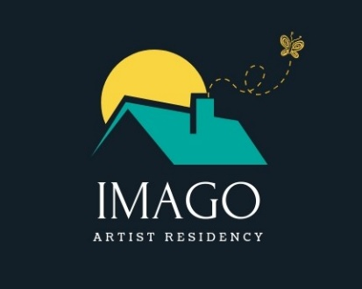

IMAGO International Artist Residency ,Village of Tsarimir (Plovdiv district ), Bulgaria.
Please, send us this application form along with your CV and Portfolio via e-mail at info@artandculture.today. If the size of the e-mail exceeds 20MB, you can send us a download link through WeTransfer.

- Basic information
Name / Surname
Recent photo
Date of Birth
Nationality
Current address
Website
Social media link
Phone and e-mail
Main artistic media(s)
How did you learn about IMAGO?

2. Residency Period Stay
Month(s)
Starting Date
End Date
The standard residency stay is 1 month. The available time periods are: June, July, August, September, October 2023

3. Motivation to be part of the residency
Do you identify with one (or a combination) of the profiles described on our webpage in the section “Is Imago the place for you?” https://www.artandculture.today/is-imago-the-place-for-you
Please, share a bit more about your motivation.
(Only in case you already know) – What type of work / concept are you planning to work on during the residency?
What is the feeling and the result you would like to have at the end of the residency?
Is there anything you would like to ask us? Any special expectations or requirements?

4. Additional information
Do you have any allergies? (related to food, animals or anything else)
Any special needs related to your daily life?

Thank you for all the information! Please, send us this application form along with your CV and Portfolio via e-mail at info@artandculture.today. If the size of the e-mail exceeds 20MB, you can send us a download link through WeTransfer. You will receive a response in about 24 hours confirming that your application has reached us. We will announce the final result again via e-mail to you in a maximum of 5 days after the end of the application period. Hope to see you soon at Imago! :)

